Name: Padam Singh

Registration No: ADIT22AP00545

NSTI Name: Mumbai

Course: ADIT

Date: 03/07/2023, Time: 10:00am

Module: Core Module 3

Requirement & tools:

* Windows 11
* Xampp
* Cmd
* Composer
* Vscode

Practical:

Question 1: Create a Laravel application to do the following :

* 1. Create a table named- ‘students’ with the following fields a) Name, b) email, c) city.
  2. Migrate this table to MySQL database named – ‘university’.
  3. After this perform rollback form the database using php artisan command.

Solution :

Follow below step’s

1. Go to the htdocs folder into the xampp folder and click on path then type cmd

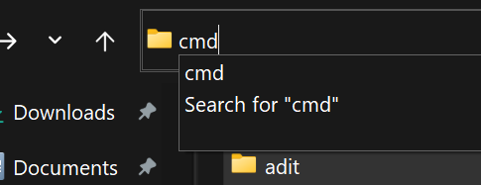

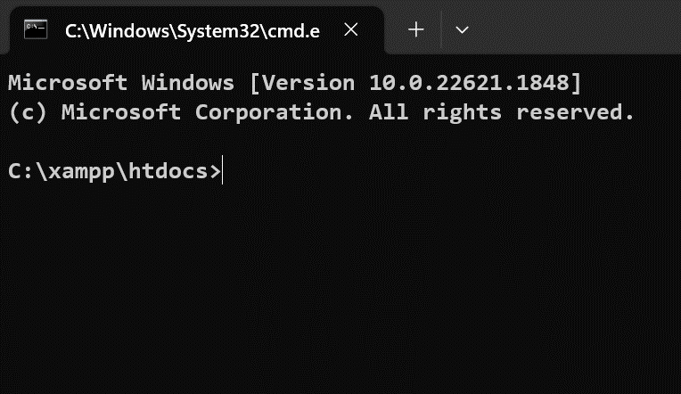

1. We need to create a Laravel folder with this command larval new adit.

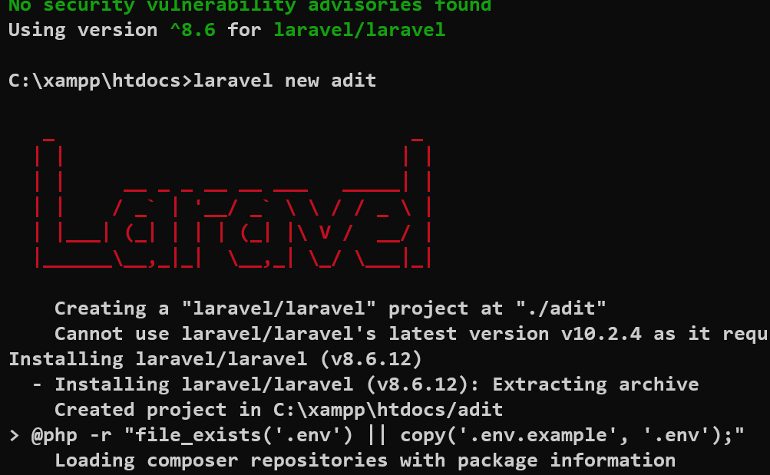

1. Open the Laravel folder(adit) into the vscode.
2. After the 3rd step you need to go .env file and add the database name ‘university’ and open terminal and run the php artisan config:cache command.

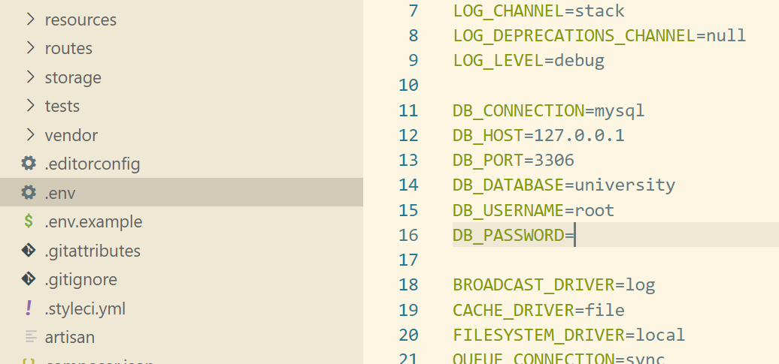

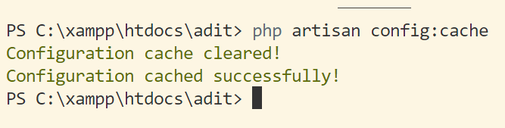

1. Know open the xampp then start mysql and click on admin.

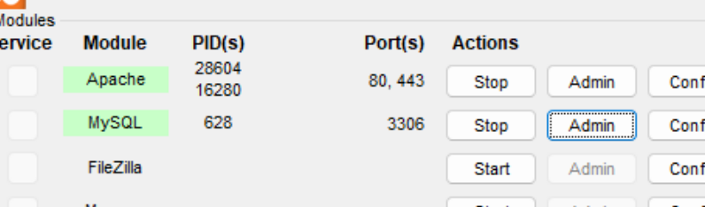

1. Create a database which name is university and clink on create.

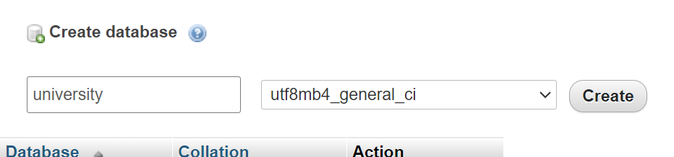

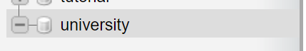

1. Create Migration and model with this command php artisan make:model Students -m

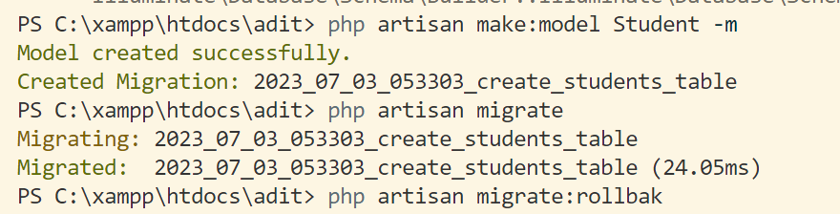

1. Insert this code into the student model and students table.

Model:

**protected** $table='students';

**protected** $primaryKey='email';

students:

 Schema::create('students', **function** (Blueprint $table) {

            $table->string('Name');

            $table->string('email');

            $table->string('city');

        });

1. After the 8th step type on terminal php artisan migrate:

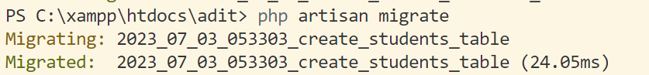

1. After the 9th step you can see a students name table create automatically into the xampp.

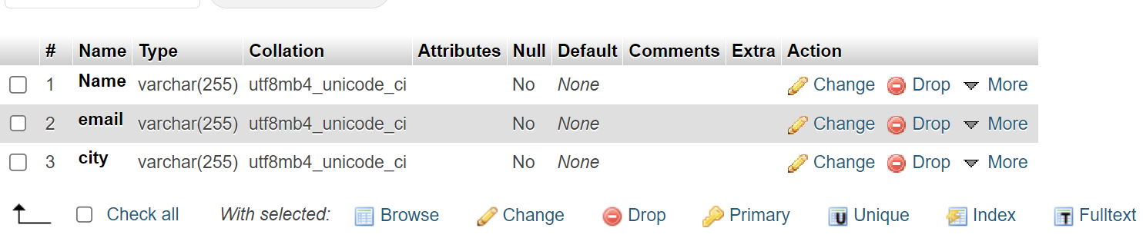

1. After that we perform the rollbak cmd type

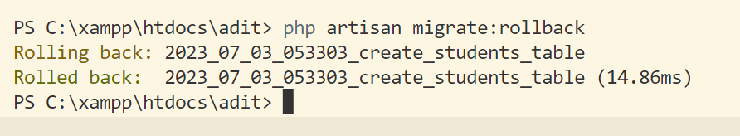

1. Know go to the xampp mysql localhost. You can see students name table deleted that’s mean rollbak successfully.

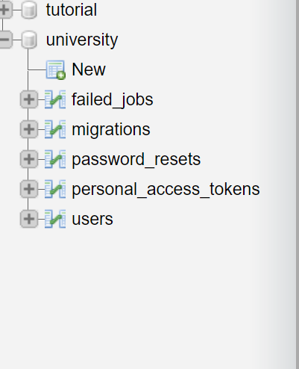

Practical:

Question 3: Using MongoDB, perform the following:

1. Create a database name – ‘company’.
2. In the database, create a collection named – ‘HRdetails’ and store 5 documents with data.
3. The fields of the document can be a) empID, b) designation, c) age.
4. Fetch the 1st document.

Solution:

Follow below step’s

1. Go to search and type cmd and open it.

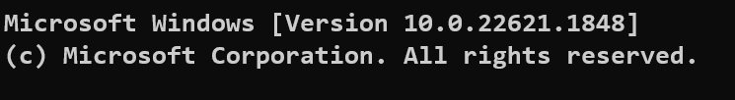

1. Type mongosh

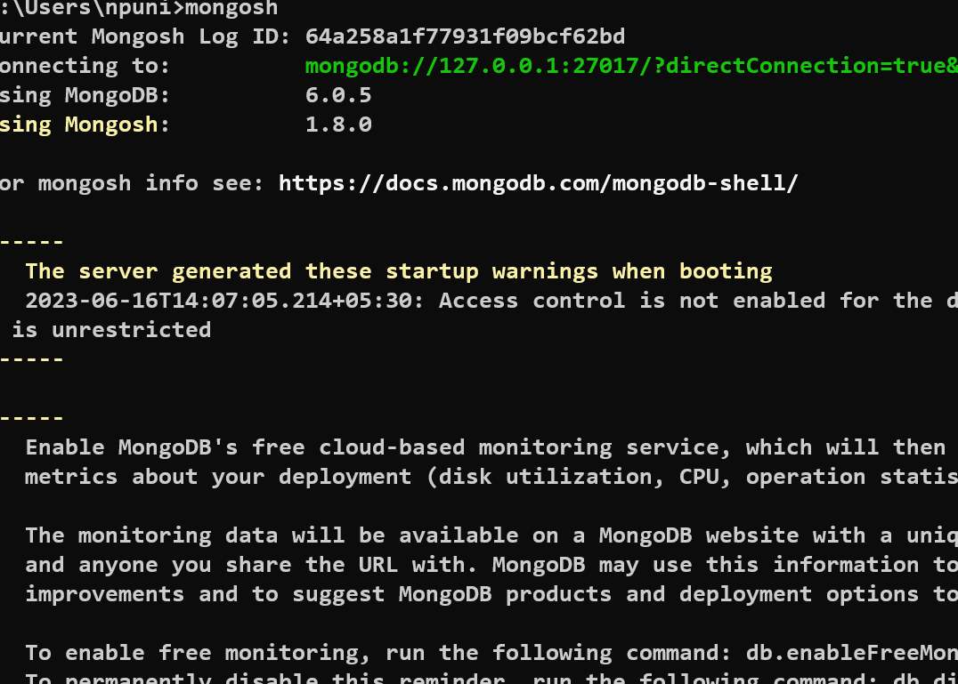

1. Show dbs for check all databases.

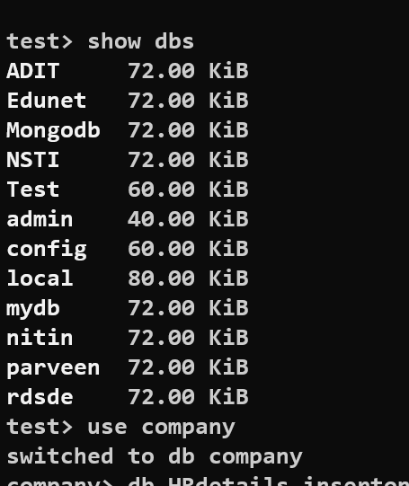

1. Create a database which name is company. Type use company and insert data.

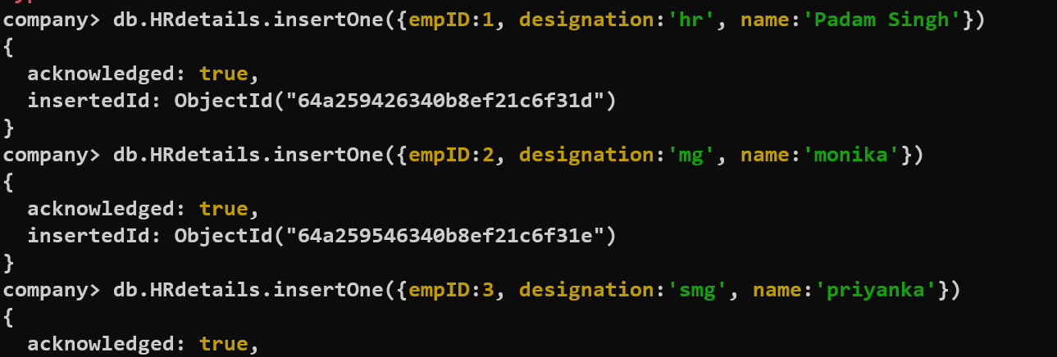

1. Fetch 1st document type db.HRdetails.find().limit(1)

